** NFC-IET UNIVERSITY, MULTAN**

**LAB REPORT**

**ICT (“Information & Communication Technology Fundamental”)**

**For the degree of Bacheller of Science in**

**Computer Science**

**Session (2k24)**

**Name: Javeria Maryam**

**Roll No: 2k24-BSCS-451**

**Section: Y**

**Submitted To: Fabiyya Hassan**

**Submitted By: Javeria Maryam**

**( 18 OCTOBER , 2024)**

**Assignment 01**

**LAB 01**

**Typing Master:**

**Introduction to typing software such as( Typing Club) to improve typing speed and accuracy. Explain the importance of regular practice. It involves using various exercises, tools, and techniques to develop muscle memory and familiarity with key placements.**

**Internal Components of Computer**

**Recognition**: Identifying components such as CPU, RAM, storage devices, power supply, motherboard, and expansion cards.

**Understanding**: Functions of each component and how they contribute to the computer’s operation.

* + 1. **Central Processing Unit (CPU):**
  + **Purpose:**

The ”brain” of the computer that calculates and computes information.

* + **Components:**

It has two components.

**Control Unit (CU):** Directs operations of the processor.

**Arithmetic Logic Unit (ALU):** Performs mathematical andlogical operations

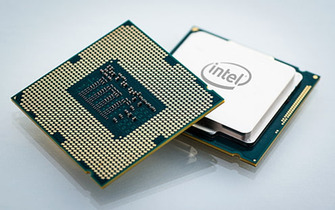

1. **Mother Board:**

**Purpose:**

The motherboard is the main circuit board that connects to everything in the computer.

**Includes:**

CPU socket, RAM slots, storage connectors, and expansion slots.

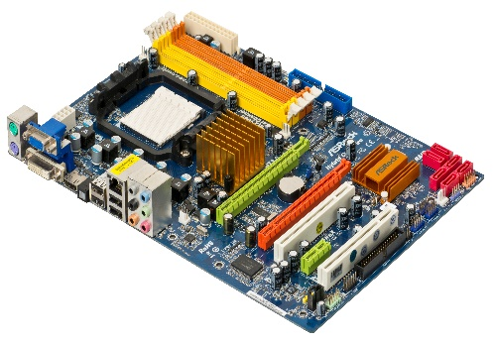

[This Photo](http://commons.wikimedia.org/wiki/file:a790gxh-128m-motherboard.jpg) by Unknown Author is licensed under [CC BY-SA](https://creativecommons.org/licenses/by-sa/3.0/)

1. **Power Supply Units:**

**Purpose:**

Converts AC to DC and distributes power to the computers components.

**Features:**

It also includes a fan to cool the computer.

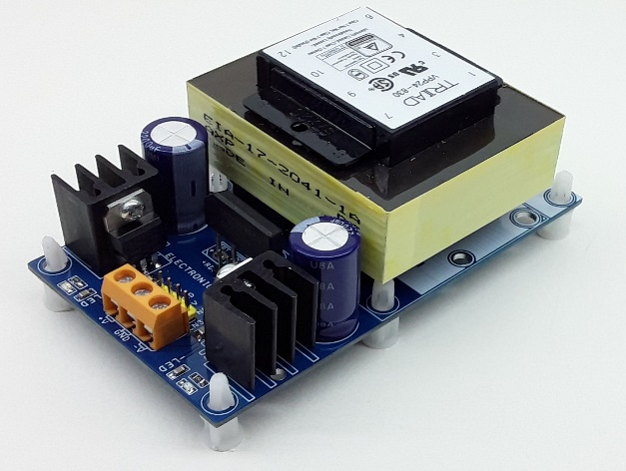

[This Photo](https://www.electronics-lab.com/tag/12v/) by Unknown Author is licensed under [CC BY-SA](https://creativecommons.org/licenses/by-sa/3.0/)

1. **Memory (RAM-Random Access Memory):**
   * **Purpose:**

Temporarily stores data and instructions currently in used by the CPU for quick access.

**Features:**

Volatile memory, meaning data is lost when power is off.

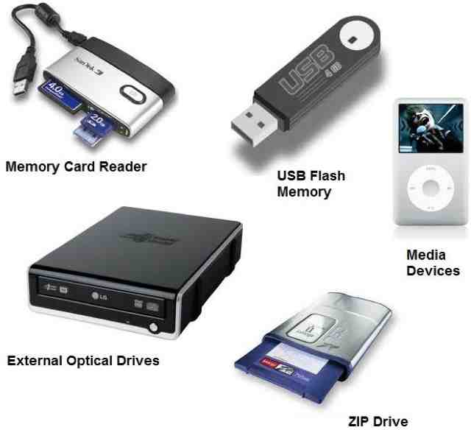

[This Photo](https://tsaponar.blogspot.com/2013/05/) by Unknown Author is licensed under [CC BY-SA](https://creativecommons.org/licenses/by-sa/3.0/)

**LAB 2**

* **Windows Installations Steps:**

**Step 1. Pre- Installation**

* + 1. Backup data
    2. Check hardware compatibility
    3. Create bootable USB(min 8GB)
    4. Disable antivirus and firewall

**Step 2. Installation Steps**

* + 1. Boot from USB
    2. Select language, time, keyboard
    3. Enter product key (if prompted)
    4. Choose installation type (Upgrade/ Custom)
    5. Partition and format drive
    6. Install windows
    7. Configure network, user account
    8. Finalize installations

**Step 3. Post- Installation**

* + 1. Update windows
    2. Install essential software
    3. Configure system settings
    4. Check driver updates
    5. Enable antivirus and firewall

**Step 4. Troubleshooting**

* + 1. Boot device issues
    2. Installation failures
    3. Driver compatibility
    4. Activation problems
    5. System restore/backup issues

**Resources:**

* + 1. Microsoft Support
    2. Windows Installation Guide
    3. You Tube tutorials
    4. Online forums (e.g., Reddit)

**NOTE:**

Remember to backup data and check hardware compatibility before installation.

* **CPU Assembling Steps**

**Step 1. Unpack and prepare Motherboard:**

Remove CPU from packing

Remove protective film from CPU socket

Locate mounting holes for stands-offs

**Step 2. Install CPU:**

* Remove CPU from packing
* Align CPU with socket (match pins)
* Gently push CPU into socket
* Secure CPU with mounting mechanism

**Step 3. Apply Thermal Paste and Install Cooler:**

* Apply thermal paste to CPU die (center)
* Install cooler )heatsink/fan or liquid cooling)
* Secure cooler with screws/clips

**Step 4. Install RAM:**

* Locate RAM slots on motherboard
* Align RAM modules with slots
* Insert RAM modules at 45-degree angle
* Secure RAM with clips

**Step 5. Install Power Supply**

* Locate power supply mounting bracket
* Install power supply
* Connect power cables to motherboard

**Step 6. Connect Front Panel and Peripherals**

* Connect front panel cables (power, reset, LEDs)
* Connect keyboard, mouse, and other peripherals

**Step 7. Final Check and Power-On**

* Double-check connections
* Plug in power cord
* Press power button
* Verify system boots and functions properly

**NOTE:**

Assembling a CPU requires attention to detail and careful handling of components.

**LAB 03**

**Motherboard and its internal structure**

**Motherboard**

* + **Purpose:**

The motherboard is the main circuit board that connects to everything in the computer.

* + **Includes:**

CPU socket, RAM slots, storage connectors, and expansion slots.



[This Photo](http://commons.wikimedia.org/wiki/file:a790gxh-128m-motherboard.jpg) by Unknown Author is licensed under [CC BY-SA](https://creativecommons.org/licenses/by-sa/3.0/)

**Internal Structure**

Motherboard has many components including:

* + - 1. **CPU Socket**

**Functions:** Connects CPU to motherboard

* + **Types**: LGA (Land Grid Array), PGA (Pin Grid Array), Socket AM4, etc.
  + **Purpose:** Provides electrical connection between CPU and motherboard

1. **Chipset**
   * **Function:** Manages data flow between components
   * **Types:** Northbridge, Southbridge, PCH (Platform Controls Hub)
   * **Purpose:** Controls data transfer, power management, and peripheral connectivity.
2. **RAM Slots (DIMM)**
   * **Functions:** Holds ram modules
   * **Types:** DDR3, DDR4, DDR5, etc.
   * **Purpose**: Provides memory for system operations**.**
3. **Expansion Slots (PCIe, PCI, AGP)**

**Functions**: Allows installation of expansion cards

**Types**: PCIe (Peripheral Component Interconnect Express), PCI, AGP (Accelerated Graphics port**)**

**Purpose:** Supports graphics cards, sound cards, network cards, etc.

**5.** **Storage connectors (SATA, IDE)**

* + **Function**: Connects storage devices (HDD, SSD, etc.)
  + **Types**: SATA (Serial Advanced Technology Attachment), IDE (Integrated Drive Electronics)
  + **Purpose**: Provides data transfer between storage devices and motherboard.
    1. **Power Connectors**
  + **Functions:** Supplies power to motherboard and components
  + **Types**: ATX (Advanced Technology Extended), AT(Advanced Technology)
  + **Purpose**: Distribute power from power supply unit (PSU) to motherboard
    1. **Input/ Output (I/O) Panel**
  + **Function**: Provides external connectivity options
  + **Includes**: USB, audio, video, LAN, PS/ 2 ports
  + **Purpose**: Allows connection to peripherals, monitors, and networks.

**NOTE**:

These 7 components form the foundation of a motherboard, enabling it to support the CPU, memory, storage, and peripherals.

**LAB 04**

**INTRODUCTION TO MS OFFICE & MS WORD BASIC FEATURES**

**INTRODUCTION TO MS OFFICE**

**Microsoft Office** is a suite of productivity tools for creating documents, spreadsheets, presentations, and more. Here's a concise overview:

* + Overview of MS Office suite (Word, Excel, PowerPoint, Outlook, Access).
    - **OVERVIEW**

1. **Word:**

For text editing, document creation, templates, and collaboration tools.

1. **Excel:**

For data analysis with formulas, charts, and PivotTables.

1. **PowerPoint:**

For presentations with multimedia, animations, and templates.

1. **Outlook:**

For email, calendar, and task management.

1. **Access:**

For creating and managing databases

* **Benefits**

Boosts productivity, easy to use, and works across devices.

**INTRODUCTION TO MS WORD**

**Microsoft Word** is a word processing application used for creating, editing, and formatting documents.

**OR**

**Microsoft Word** is a widely used word processing software developed by Microsoft. It allows users to create, edit, format, and print documents such as reports, letters, and resumes.

**KEY FEATURES**

Here is the detailed description of the key features of MS Word.

**Document Creation**

MS Word allows you to create new document from scratch. You can choose from various templates or start with a blank page.

**Text Editing**

MS Word provides a range of text editing tools, including:

* + - Font styles (bold, italic, underline)
    - Font sizes and colors
    - Text alignment (left, center, right)
    - Cut, Copy, and Paste options

**Formatting**

MSWord allows you to customize the layout and appearance of your document, including:

* Margin settings (top, bottom, left, right)
* Page orientation (portrait, landscape
* Line spacing and indentation
* Header and Footer options

**Image and Multimedia**

MS Word enables you to insert image, audio, and video files into your document, including:

* Pictures insertion from files or online sources
* Audio and video file insertion
* Image editing and formatting options

**Tables and Charts**

MS Word provides tools to create and customize tables and charts, including:

* Table creation and formatting
* Chart creation (bar, column, line pie)
* Data analysis and visualization option

MS Word allows you to add headers and footers to your document, including:

* Header and Footer creation and formatting
* Page numbering and date options

**Printing and Sharing**

* Printing options (paper size, orientation, margins)
* Saving options (file format, location)
* Sharing options (email, cloud storage, social media)

**Real-time Collaboration**

MS Word allows real-time collaboration with others, including:

* Simultaneous editing
* Commenting and tracking changes
* Version history and recovery options

**Accessibility Features**:

* Read aloud, dictation, and translation tools.
* Accessibility checker to ensure document inclusivity.

**Smart Lookup**:

* Provides definitions, Wikipedia entries, and web searches for highlighted text.

**Uses of Microsoft Word:**

**\*Document Creation\***

* Letters, Reports, CV Resumes, Essays, Brochures, Newsletters, Meeting Agendas, Minutes, Proposals, Flyers, Invoices, Forms, Labels, Calendars, E-books, Templates, Web Pages, Books, Diaries and Journals & Scripts.

**\*Home Tab\***

**\*Clipboard*:** Cut, copy, paste, format painter.

**\*Font*:** Font style, size, bold, italic, underline, text color, highlighting.

**\*Paragraph*:** Alignment, indentation, line spacing, lists (bulleted/numbered), borders.

**\*Styles*:** Quick Styles, apply styles to text.

**\*Editing*:** Find, replace, select.

• **Uses**: Basic text formatting and editing.

• **Key Features**:

* **Clipboard**: Cut (Ctrl + X), Copy (Ctrl + C), Paste (Ctrl + V).
* **Font**: Bold (Ctrl + B), Italic (Ctrl + I), Underline (Ctrl + U).
* **Paragraph**: Align Left (Ctrl + L), Center (Ctrl + E), Right (Ctrl + R), Justify (Ctrl + J), Increase Indent (Ctrl + M), Decrease Indent (Ctrl + Shift + M).
* **Styles**: Apply quick styles using keyboard shortcuts (e.g., Heading 1: Ctrl + Alt + 1).

• **Shortcuts**:

* Format Painter (Ctrl + Shift + C, Ctrl + Shift + V).

**\*Insert Tab\***

**\*Pages*:** Cover page, blank page, page break.

**\*Tables*:** Insert tables, table styles.

*Illustrations*: Insert pictures, shapes, icons, 3D models, screen shots.

**\*Links*:** Hyperlink, bookmarks, cross references.

**\*Header & Footer*:** Insert/edit headers/footers, page numbers.

**\*Text*:** Insert text boxes, WordArt, signatures, equations, symbols.

**\*Media*:** Insert online videos.

• **Uses**: Adding various elements to a document.

• **Key Features**:

* **Pages**: Insert Cover Page.
* **Tables**: Insert Table (Alt + N, T).
* **Illustrations**: Insert Picture (Alt + N, P), Insert Shape (Alt + N, S).
* **Links**: Hyperlink (Ctrl + K).

• **Shortcuts**:

* Insert Page Break (Ctrl + Enter).

**\*Design Tab\***

**\*Document Formatting*:** Themes, colors, fonts, effects.

**\*Page Background*:** Watermark, page color, page borders.

**\*Document Formatting*:** Style sets.

• **Uses**: Formatting the overall document design.

• **Key Features**:

* **Document Formatting**: Change Themes (Alt + G, H).
* **Page Background**: Watermark (Alt + G, B, W).

• **Shortcuts**: Not many shortcuts, mostly accessed via the ribbon.

**\*Layout Tab\***

**\*Page Setup*:** Margins, orientation, size, columns.

**\*Paragraph*:** Indentation and spacing settings.

**\*Arrange*:** Position, wrap text, bring forward/send backward for overlapping objects.

• **Uses**: Page layout and settings.

• **Key Features**:

* **Page Setup**: Margins (Alt + P, M), Orientation (Alt + P, O).
* **Paragraph**: Spacing settings (Alt + P, A).

• **Shortcuts**:

* Open Page Setup Dialog (Alt + P, S, P).

**\*References Tab\***

**\*Table of Contents*:** Insert, update, and customize TOC.

**\*Footnotes*:** Insert footnotes and endnotes.

**\*Citations & Bibliography*:** Manage sources, insert citations, create bibliography.

**\*Captions*:** Insert captions for figures and tables.

**\*Index*:** Mark entries and insert an index.

• **Uses**: Creating citations and references.

• **Key Features**:

* **Table of Contents**: Insert TOC (Alt + S, T).
* **Citations & Bibliography**: Insert Citation (Alt + S, C).

**\*Mailings Tab\***

**\*Create*:** Start mail merge, select recipients.

\***Write & Insert Fields*:** Insert merge fields into documents.

**\*Preview Results*:** View merged documents.

**\*Finish*:** Complete and print the merged documents.

• **Uses**: Creating mail merges and labels.

• **Key Features**:

* **Create**: Start Mail Merge (Alt + M, M).
* **Finish**: Complete Mail Merge (Alt + M, F).

• **Shortcuts**: Not many shortcuts; mostly accessed via the ribbon

**\*Review Tab\***

**\*Proofing*:** Spelling and grammar check, thesaurus.

\***Language*:** Language settings and translation.

\***Comments*:** Add, edit, and delete comments.

**\*Tracking*:** Track changes, accept/reject changes.

**\*Changes*:** Compare and combine documents.

• **Uses**: Reviewing and editing documents.

• **Key Features**:

* **Proofing**: Spelling and Grammar (F7).
* **Comments**: New Comment (Ctrl + Alt + M).
* **Tracking**: Track Changes (Ctrl + Shift + E).

• **Shortcuts**:

* Accept Change (Alt + Shift + A).
* Reject Change (Alt + Shift + R).

**\*View Tab\***

**\*Document Views*:** Switch between print layout, web layout, outline, draft.

**\*Show*:** Ruler, gridlines, navigation pane.

\***Zoom*:** Zoom in/out, 100% zoom.

**\*Window*:** New window, arrange all, split, switch windows.

• **Uses**: Changing document views and layouts.

• **Key Features**:

* **Document Views**: Switch views (Alt + W).
* **Show**: Toggle Ruler (Alt + W, R).
* Zoom In (Ctrl + Alt + +),
* Zoom Out (Ctrl + Alt + -).

**\*Help Tab\***

Provides access to help features and online resources.

• **Key Features**: Search for help topics, access training resources.

• **Shortcuts**:

* Help (F1)

**\*Additional Tabs\***

**\*File Tab*:** Access to Backstage view for file management (new, open, save, print).

\***Contextual Tabs*:** Appear when certain objects (like images, tables, charts) are selected, offering specific tools related to that object.

* **File Tab**: Access Backstage view.
  + **Shortcuts**: New Document (Ctrl + N), Open Document (Ctrl + O), Save Document (Ctrl + S), Print (Ctrl + P).

**Benefits:**

* Powerful document creation and formatting tools.
* Collaboration and cloud-based access.
* Widely compatible and professional results.

**LAB 05**

**MS WORD ADVANCED FEATURES**

**MAIL MERGE**

**Mail merge** is a feature in MS Word that allows you to create personalized letters, emails, labels and envelops for large groups of people.

**Steps to perform a Mail Merge**

Here are the steps to perform a Mail Merge:

**Start the Mail Merge Process**

* Go to “Mailings” tab in the ribbon.
* Click on “Start Mail Merge” and select “Step-by-Step Mail Merge Wizard”.

**Select Data Source**

* Choose the table or worksheet that contains the data you want to merge

**Insert Merge Fields**

* Click on “Insert Merge Field” and select the field you want to insert.
* Repeat this process for each merge field you want to insert.

**Complete the Merge**

* Click on “Finish and Merge” to complete the merge process.
* Choose whether you want to print the documents, send them via email, or save them to a file.

**TABLE OF CONTENTS (TOC)**

A **Table of Content (TOC)** is a list of headings and subheadings in a document. It helps readers navigate the document and find specific sections easily.

**Steps to create a Table of Content:**

**Apply Headings Styles**

* Select each heading and apply a heading style (e.g., Heading 1, Heading2, etc.)

**Go to Reference Tab**

* Click on the References tab in the ribbon.

**Click on Table of Contents**

* Click on the Table of Contents button in the Table of Contents group.

**Choose a TOC Style**

* Select a TOC style from the gallery or choose “Custom Table o Contents” to create your own
* **SECTION BREAKS**

**Section breaks** are used to divide a document into separate sections, each with its own formatting, layout, and pagination.

**Types of Section Breaks:**

1. **Next Page**: Start a new section on the next page.
2. **Continuous**: Start a new section on the same page.
3. **Even Page**: Starts a new section on the next even-numbered page.
4. **Odd Page**: Starts a new section on next odd-numbered page.

* **REFERENCES**

Adds citations, footnotes, endnotes, and bibliographies to a document.

**KEY FEATURES**

**CITATION STYLES:** Supports various citation styles, including APA, MLA Chicago and more.

**Bibliography Management**: Automatically generates and updates bibliography based on your citations.

**Footnote and Endnote Management**: Easily insert, edit, and manages footnotes and endnotes.

* **Headers and Footers**

**Headers and footers** are areas at the top and bottom of a page that contain information such as page numbers, titles, and dates.

**Header:** Appears at the top of a page.

**Footer:** Appears at the bottom of the page.

**Steps to create Header and Footer**

* Go the “insert” tab in MS Word.
* Click on “Header or “Footer” to create a new “Header” or “Footer”.
* Design your Header or Footer using the tools and options available.
* Click “OK” to save tour changes.

**EFFICIENT USAGE TIPS:**

**Mail Merge:**

**Mail merge** is a feature in MS Word that allows you to create personalized letters, emails, labels and envelops for large groups of people.

**Table of Content (TOC):**

A **Table of Content (TOC)** is a list of headings and subheadings in a document. It helps readers navigate the document and find specific sections easily.

**Section Breaks:**

**Section breaks** are used to divide a document into separate sections, each with its own formatting, layout, and pagination.

**References:**

References are used to add citations, footnotes, endnotes, and bibliographies to a document.

**Headers and Footers:**

**Headers and footers** are areas at the top and bottom of a page that contain information such as page numbers, titles, and dates.

**LAB 06**

### **Using Mendeley, Grammarly & PDF Element; Macros and Automation**

1. **Tools for Document Enhancement**:

**MENDELEY:**

**Mendeley** helps manage and organize your research papers, create citations, and generate bibliographies.

**Key Features:**

**Reference Management:** Store Organize, and tag references from various sources.

**Citation and Bibliography:** Generate citations and bibliographies in various styles (e.g., APA, MLA, Chicago).

**PDF Annotation:** Annotate and highlight PDF, s and extract annotations.

**Collaboration:** Share and collaborate on research papers and libraries with others.

**Discovery:** Discover new research papers and authors based on your interests.

**Steps**:

1. **Install Mendeley**:

Download and install Mendeley Desktop from [Mendeley’s website](https://www.mendeley.com)

1. **Add Documents**:

Import PDFs or manually add references using the "Add Document" option.

1. **Use Mendeley with Word**:

Install the Mendeley Word Plugin to easily insert citations and generate bibliographies.

* + **Insert Citations**:

Click **References > Insert Citation** and search your Mendeley library.

* + **Generate Bibliography**:

Once all citations are added, Mendeley can create a bibliography with the **Insert Bibliography** button.

### **Grammarly (Grammar and Writing Assistance)**

Grammarly helps with grammar checking, spelling correction, style improvement, and plagiarism detection.

**Key Features:**

**Grammar and Spell Check:** Identifies and corrects grammatical errors, spelling mistakes and punctuation errors.

**Plagiarism Detection:** Checks for plagiarism and provides citations for referenced source.

**Style and Clarity:** Suggests improvements for sentence structure, word choice and tone.

**Vocabulary Enhancement:** Provide synonyms and word suggestions to enhance writing.

**Citation and Bibliography:** Generates citations and bibliographies in various styles (e.g., APA, MLA, Chicago ).

**Steps**:

1. **Install Grammarly**:

Download the Grammarly plugin for your browser, or use the desktop app.

1. **Use in Word**:

Grammarly integrates with Microsoft Word and Outlook to check grammar while you write.

1. **Proofread**:

Review suggestions in the Grammarly sidebar and accept/reject them as needed.

### **PDF Element (PDF to Word Conversion Tool)**

A PDF to Word conversion tool is a software or online services that converts Portable Document Format (PDF) files into editable MS Word (.dox) documents.

**Key Features:**

**Conversion Accuracy**: Preserves original layout, formatting, and content.

**Text Editing:** Allows editing of converted text in MS Word.

**Image and Table Preservation:** Retains images and tables from the original PDF.

**Batch Conversion:** Converts multiple PDFs to word documents simultaneously.

**Steps**:

1. **Install PDF Element**: Download and install PDF Element from Wondershare's website.
2. **Convert PDF to Word**:
   * Open the PDF in PDF Element.
   * Click on **Convert** and select **To Word**.
3. **Edit PDF**: Use the **Edit** tab to modify text, images, or add annotations.
4. **OCR**:

If the PDF is a scanned image, use the **OCR** feature to extract editable text.

1. **Automation with Macros:**

Macros area powerful tool for automating repetitive tasks in various software applications. Here’s how automation with macros works:

**Steps to Create Macros**

**Record a Macro:** Automate repetitive tasks to free up time for more important work.

**Improved Accuracy:** Reduce errors by automating tasks that are prone to human mistake.

**Enhanced Efficiency:** Streamline processes and workflow to achieve more in less time.

### **Referencing Tools for Citations, Footnotes, and Endnotes**

**Purpose**:

These tools help you create proper citations, footnotes, and endnotes within Word documents.

**Steps**:

* **Insert Citations**:
  1. Use **References > Citations & Bibliography** to insert citations from your selected referencing style.
  2. Click **Insert Citation** to choose or add a source.
* **Insert Footnotes/Endnotes**:

1. Go to **References > Insert Footnote** to insert footnotes.
2. For endnotes, click **Insert Endnote**. Both footnotes and endnotes will be numbered automatically.

* **Manage Sources**:

Use **Manage Sources** to store and edit your citations for future use in documents.

**LAB 07**

* **MAIL MANAGEMENT**

The process of organizing, prioritizing and responding to emails in efficient and effective manner.

* + Using Outlook or other mail clients for organized communication.

**Key Features:**

1. Email organization
2. Prioritization
3. Automated responses
4. Integration with task management tools
5. Spam filtering

* **Collaborative Tools (Track Changes & Comments, Reviewing & Comparing Documents)**

Software applications or platforms that enable teams to work together, share information, and communicate effectively.

* + **Track Changes & Comments**: Efficiently manage edits and feedback.
  + **Reviewing & Comparing Documents**: Ensuring consistency across different versions.

**Key Features**:

1. Real-time messaging
2. File Sharing
3. Video Conferencing
4. Task Assignment
5. Project Management

* **Data PROTECTION (PROTECT DOCUMENTS WITH PASSWORDS AND CONTROL EDITING PERMISSIONS)**

Data Protection refers to the practices, policies, and technologies used to secure and protect sensitive data from unauthorized access, theft, corruption, or loss.

* + **Password Protection**: How to secure documents.
  + **Control Editing Permissions**: Restricting access and editing rights for sensitive documents.

**Key Features**::

1. Encryption
2. Access control
3. Backup and Recovery
4. Compliance
5. User Authentication

**PRACTICAL WORK OF MS WORD FEATURES PERFORMED IN LAB**

**For Random Paragraph:**

**=rand()**

Video provides a powerful way to help you prove your point. When you click Online Video, you can paste in the embed code for the video you want to add. You can also type a keyword to search online for the video that best fits your document.

To make your document look professionally produced, Word provides header, footer, cover page, and text box designs that complement each other. For example, you can add a matching cover page, header, and sidebar. Click Insert and then choose the elements you want from the different galleries.

Themes and styles also help keep your document coordinated. When you click Design and choose a new Theme, the pictures, charts, and SmartArt graphics change to match your new theme. When you apply styles, your headings change to match the new theme.

Save time in Word with new buttons that show up where you need them. To change the way a picture fits in your document, click it and a button for layout options appears next to it. When you work on a table, click where you want to add a row or a column, and then click the plus sign.

Reading is easier, too, in the new Reading view. You can collapse parts of the document and focus on the text you want. If you need to stop reading before you reach the end, Word remembers where you left off - even on another device.

**Formatting:**

Video provides a powerful way to help you prove your point. When you click Online Video**, you can paste in the embed code for the video you want to add. You can also type a keyword to search online for the video that best fits your document.**

**To make your document look professionally produced, Word provides header, footer, cover page, and text box designs that complement each other. For example, you can add a matching cover page, header, and sidebar. Click Insert and then choose the elements you want from the different galleries.**

**Themes and styles also help keep your document coordinated. When you click Design and choose a new Theme, the pictures, charts, and SmartArt graphics change to match your new theme. When you apply styles, your headings change to match the new theme.**

**Save time in Word with new buttons that show up where you need them. To change the way a picture fits in your document, click it and a button for layout options appears next to it. When you work on a table, click where you want to add a row or a column, and then ~~click the plus sign~~.**

**Reading is easier, too, in the new Reading view. You can collapse parts of the document and focus on the text you want. If you need to stop reading before you reach the end, Word remembers where you left off - even on another device.**

**Insert Tables:**

|  |  |  |  |
| --- | --- | --- | --- |
| **Student Details** | | | |
| Roll No. | Name | Section | Class |
| 2k24-BSCS-451 | Javeria Maryam | Y | ICT |
|  |  |  |  |
|  |  |  |  |
|  |  |  |  |
|  |  |  |  |

**Insert Shapes:**

**Smiley**

**Information and Communication Technology**

**No Entry**

**Insert Images:**

**Picture into Picture:**

|  |  |  |  |  |  |  |
| --- | --- | --- | --- | --- | --- | --- |
| December | | | | | | |
| M | T | W | T | F | S | S |
|  |  |  |  |  |  | 1 |
| 2 | 3 | 4 | 5 | 6 | 7 | 8 |
| 9 | 10 | 11 | 12 | 13 | 14 | 15 |
| 16 | 17 | 18 | 19 | 20 | 21 | 22 |
| 23 | 24 | 25 | 26 | 27 | 28 | 29 |
| 30 | 31 |  |  |  |  |  |
|  |  |  |  |  |  |  |

**Insert Calendar:**

#December 🡪 bookmark link

**Table of Content:**

Introduction 2

Uses 3

Features 4

Design 5

Importance 6

Role in Daily Life 7

# **Insert Headings:**

# Introduction:

Video provides a powerful way to help you prove your point. When you click Online Video, you can paste in the embed code for the video you want to add. You can also type a keyword to search online for the video that best fits your document.

## Uses:

To make your document look professionally produced, Word provides header, footer, cover page, and text box designs that complement each other. For example, you can add a matching cover page, header, and sidebar. Click Insert and then choose the elements you want from the different galleries.

### Features:

Themes and styles also help keep your document coordinated. When you click Design and choose a new Theme, the pictures, charts, and SmartArt graphics change to match your new theme. When you apply styles, your headings change to match the new theme.

Save time in Word with new buttons that show up where you need them. To change the way a picture fits in your

# Design:

Document, click it and a button for layout options appears next to it. When you work on a table, click where you want to add a row or a column, and then click the plus sign.

## Importance:

Reading is easier, too, in the new Reading view. You can collapse parts of the document and focus on the text you want. If you need to stop reading before you reach the end, Word remembers where you left off - even on another device.

### Role in Daily Life:

Video provides a powerful way to help you prove your point. When you click Online Video, you can paste in the embed code for the video you want to add. You can also type a keyword to search online for the video that best fits your document.

**Mathematical Equations:**

* 9

**Subscript:**

6796

**Superscript:**

**3698**

**Screenshots:**

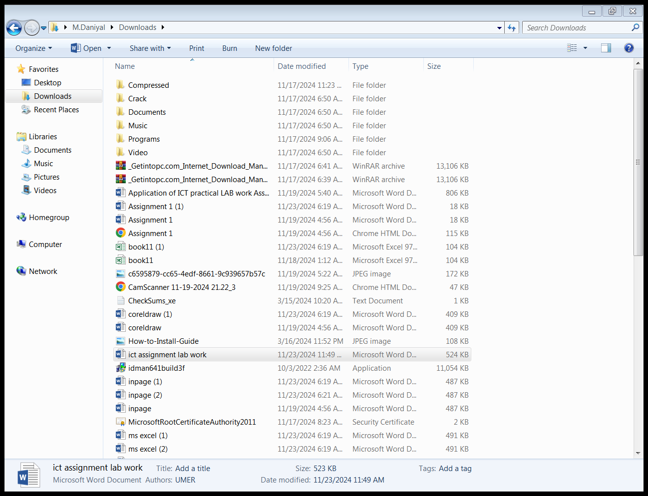

## **Link:**

NFC-IET-Multan-Logo.jpg

**Line Spacing:**

My name is Javeria Maryam**.**

My hobby is Reading Books.

I am student of BSCS.

I like outings.

I like to explore.

**Insert Charts:**

# ===

**LAB 08**

**INTRODUCTION TO MS EXCEL AND BASIC SKILLS**

**Microsoft Excel** is a spreadsheet program that enables users to store data in tables, perform calculations using formulas, and create visual data representations like charts and graphs. It is part of the Microsoft Office suite and is commonly used in business, accounting, data analysis, and various administrative tasks.

**Features of Microsoft Excel:**

Home, Insert, Layout, Formulas, Data, Review, View.

**Uses OF MS Excel:**

* **Data Organization and Management**:
  + Excel allows users to store and manage large amounts of data. It can organize data in rows and columns, making it easier to read and manipulate.
* **Data Analysis**:
  + Excel provides tools like pivot tables, filters, and advanced formulas that help users analyze data trends and insights, making it useful for data analysis and reporting.
* **Financial Modeling**:
  + Excel is extensively used for creating financial models, budgeting, forecasting, and other financial tasks like cash flow analysis and investment planning.
* **Automation with Macros**:
  + Excel supports Visual Basic for Applications (VBA), allowing users to automate repetitive tasks and customize processes with macros.
* **Visualization**:
  + Excel provides a variety of chart types (pie charts, bar graphs, line charts) and formatting tools that help in visualizing data trends and presenting information clearly.
* **Data Entry and Calculation**:
  + You can use Excel to enter and store numerical data, apply formulas to perform automatic calculations, and use functions like SUM, AVERAGE, COUNT, and IF to process data.
* **Project Management**:
  + Excel is often used for creating project timelines, tracking progress, and managing resources with features like Gantt charts and resource allocation tools.
* **Inventory Management**:
  + Businesses use Excel to maintain inventory lists, track stock levels, and forecast inventory needs by analyzing historical data.
* **Business Reporting**:
  + Many businesses use Excel to prepare reports on sales, performance metrics, and customer data, making it a versatile tool for business reporting.
* **Statistical Analysis**:
  + Excel provides built-in statistical functions and tools, such as regression analysis, which can be useful for researchers and data scientists to analyze datasets.

**Home Tab:**

The Home tab provides access to the most commonly used tools and commands:

**Clipboard:** Cut, Copy, Paste, and Format Painter.

**Font:** Change font style, size, color, and apply bold, italic, underline, etc.

**Alignment:** Align text (left, center, right), merge cells, wrap text, and adjust orientation.

**Number:** Format numbers as currency, percentage, dates, and other number formats.

**Styles:** Apply predefined styles to cells, such as headings, titles, or conditional formatting.

**Cells:** Insert, delete, and format cells, rows, and columns.

**Editing:** Find, replace, and use functions like AutoSum and Sort.

**Common Uses**: Formatting cells, copying/pasting, sorting data, and performing basic edits.

* **Clipboard**: Cut (Ctrl + X), Copy (Ctrl + C), Paste (Ctrl + V), Format Painter.
* **Font**: Bold (Ctrl + B), Italic (Ctrl + I), Underline (Ctrl + U), Change font size/color.
* **Alignment**: Align text left, center, or right; Merge cells; Wrap text.
* **Number**: Apply number formats such as currency, percentage, and dates.
* **Editing**: AutoSum (Alt + =), Sort and Filter, Find (Ctrl + F), Replace (Ctrl + H).

**Shortcut to Home Tab**: **Alt + H**

**Insert Tab:**

The Insert tab is used for inserting different elements into the worksheet:

**Tables:** Insert tables and pivot tables.

**Illustrations:** Insert pictures, shapes, icons, and SmartArt.

**Charts:** Create various types of charts like pie, bar, line, and scatter plots.

**Links:** Add hyperlinks to your worksheet.

**Text:** Insert text boxes, headers, footers, and WordArt.

**Symbols:** Insert equations and symbols.

**Common Uses**: Inserting tables, charts, images, and shapes.

* **Tables**: Insert table (Ctrl + T), PivotTables.
* **Illustrations**: Insert pictures, shapes, icons, and SmartArt.
* **Charts**: Create various charts (Alt + N + C for column charts, Alt + N + P for pie charts).
* **Links**: Add hyperlinks (Ctrl + K).
* **Text**: Insert text box, header, footer, and WordArt.

**Shortcut to Insert Tab**: **Alt + N**

**Page Layout Tab:**

The Page Layout tab helps with setting up the appearance and layout of your worksheet:

**Themes:** Change the overall theme of the workbook.

**Page Setup:** Set margins, orientation (portrait or landscape), size, and print area.

**Scale to Fit:** Scale the sheet to fit a specific number of pages.

**Sheet Options:** Display or hide gridlines and headings.

**Arrange:** Arrange objects like images and charts on the sheet.

**Shortcut to Page Layout Tab**: **Alt + P**

**Formulas Tab:**

The Formulas tab provides access to various Excel formulas and functions:

**Function Library:** Insert functions like Financial, Logical, Text, Date/Time, Lookup & Reference, Math, and more.

**Defined Names:** Create, edit, or delete named ranges.

**Formula Auditing:** Tools for evaluating formulas, like tracing precedents, dependents, and error checking.

**Calculation:** Set calculation options (automatic, manual, etc.).

**Common Uses**: Inserting formulas, working with named ranges, and formula auditing.

* **Function Library**: Insert functions (Alt + M + F for Function dialog).
* **Defined Names**: Name a range (Ctrl + F3), use named ranges in formulas.
* **Formula Auditing**: Trace precedents and dependents, check for errors (Alt + M + P).
* **Calculation**: Set automatic or manual calculation (Alt + M + X for calculation options).

**Shortcut to Formulas Tab**: **Alt + M**

**Data Tab:**

The Data tab allows you to manage, filter, and analyze data:

**Get & Transform Data:** Import data from various sources like databases, web, or text files.

**Sort & Filter:** Sort data or apply filters.

**Data Tools:** Tools like Data Validation, Text to Columns, Remove Duplicates, Flash Fill, and Consolidate.

**Forecast:** Tools for creating forecasts, such as whatif analysis and scenario manager.

**Outline:** Group or ungroup data, and subtotal.

**Common Uses**: Sorting, filtering, data analysis, and importing/exporting data.

* **Sort & Filter**: Sort data (Alt + A + S), apply filters (Ctrl + Shift + L).
* **Data Tools**: Text to Columns (Alt + A + E), Remove Duplicates, Data Validation (Alt + A + V + V).
* **Get & Transform**: Import data from external sources.
* **What-If Analysis**: Perform scenario analysis and goal seek.

**Shortcut to Data Tab**: **Alt + A**

**Review Tab:**

The Review tab offers tools related to reviewing and collaborating on a worksheet:

**Proofing:** Tools for spelling and grammar checks, and thesaurus.

**Accessibility:** Check the accessibility of the document.

**Comments:** Add, delete, or navigate through comments.

**Protect:** Protect sheets or the entire workbook, or share workbooks with others.

**Common Uses**: Proofreading, commenting, and protecting worksheets.

* **Proofing**: Spell check (F7).
* **Comments**: Insert comments (Shift + F2), navigate comments.
* **Protect**: Protect sheet (Alt + R + P), protect workbook.
* **Track Changes**: Enable or disable tracking of changes.

**Shortcut to Review Tab**: **Alt + R**

**View Tab:**

The View tab allows you to change the view settings of your worksheet:

**Workbook Views:** Switch between Normal, Page Layout, and Page Break views.

**Show:** Show or hide elements like gridlines, headings, and formula bars.

**Zoom:** Adjust the zoom level of the worksheet.

**Window:** Tools like Freeze Panes, Split, and Arrange Windows.

**Macros:** View, record, and manage macros.

**Common Uses**: Managing workbook views, freezing panes, and splitting windows.

* **Workbook Views**: Switch to Page Layout or Page Break view (Alt + W + I for Page Layout).
* **Freeze Panes**: Freeze rows/columns (Alt + W + F + F for Freeze Panes).
* **Zoom**: Adjust zoom level (Alt + W + Q).
* **Show/Hide**: Toggle gridlines, headings, formula bar.
* **Macros**: Record macros (Alt + W + M + R), view macros (Alt + F8).

**Shortcut to View Tab**: **Alt + W**

**Help Tab:**

The Help tab provides access to Excel’s help resources:

**Help:** Search for help topics and tips.

**Training:** Access online training resources.

**Feedback:** Provide feedback to Microsoft about Excel.

**Common Uses**: Accessing help resources and online tutorials.

* **Help**: Open Help (F1).
* **Feedback**: Provide feedback to Microsoft.

**Shortcut to Help Tab**: **Alt + Y**

**Developer Tab (Optional, but can be enabled via settings):**

The Developer tab provides advanced features for working with macros, VBA, and form controls:

**Code:** Tools for creating and managing VBA code and macros.

**Addins:** Manage Excel addins.

**Controls:** Insert form controls like buttons, checkboxes, etc.

**XML:** Import and manage XML data.

**Common Uses**: Working with macros, VBA, and form controls.

* **Code**: Open VBA editor (Alt + F11), record a macro (Alt + L + R).
* **Controls**: Insert form controls like buttons, checkboxes.
* **XML**: Import/export XML data.

**Shortcut to Developer Tab**: **Alt + L** (if enabled).

**General Key Board Shortcuts:**

* **Save**: Ctrl + S
* **Open**: Ctrl + O
* **New Workbook**: Ctrl + N
* **Close Workbook**: Ctrl + W
* **Undo**: Ctrl + Z
* **Redo**: Ctrl + Y
* **Select Entire Row**: Shift + Space
* **Select Entire Column**: Ctrl + Space
* **Go to a Cell**: Ctrl + G (or F5)
* **Insert New Worksheet**: Shift + F11
* **Switch Between Worksheets**: Ctrl + Page Up/Page Down
* **Insert Comment**: Shift + F2

**Functions**:

**Mathematical Functions:**

• **SUM:** Adds numbers in a range.

**FORMULA:**

=SUM (A1:A3)

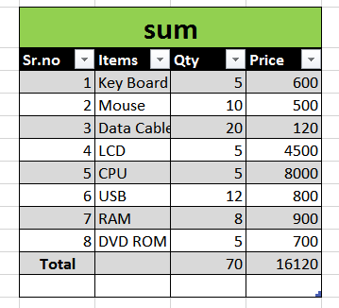

* **PRODUCT:** Product of Numbers.

**FORMULA:**

=PRODUCT (A1:A3)

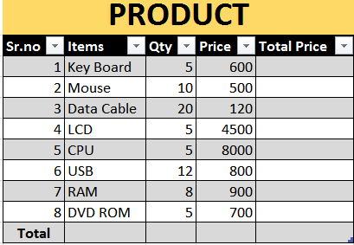

* **SUM PRODUCT:** SUM and Product of numbers.

**FORMULA:**

=SUMPRODUCT (A1:A3)

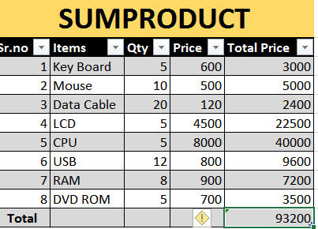

**• AVERAGE:** Calculates the mean.

**FORMULA:**

=AVERAGE (B1:B3)

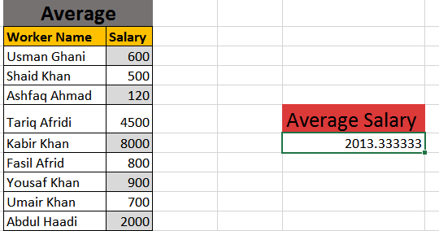

• **MAX:** Finds the largest number.

**FORMULA:**

=MAX (C1:C3)

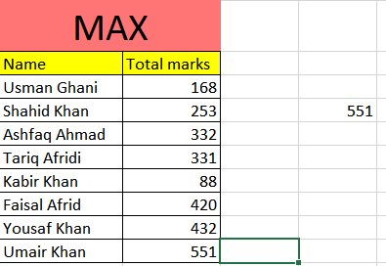

**• MIN:** Finds the smallest number.

**FORMULA:**

=MIN (D1:D3)

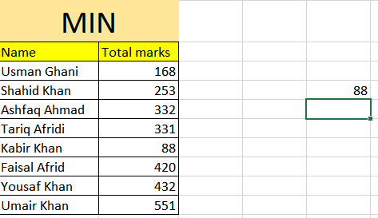

.**Text Functions:**

• CONCATENATE/CONCAT: Joins text.

**Formula:**

=CONCAT (A1, B1)

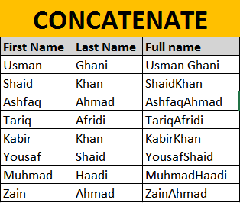

**LEN:** Counts characters in a string.

**Formula:** =LEN ("Chat GPT")

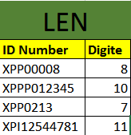

**Date and Time Functions:**

**• TODAY:** Returns the current date.

**Formula**: =TODAY ()

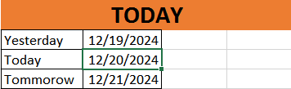

• **NOW:** Returns the current date and time.

**Formula:** =NOW ()

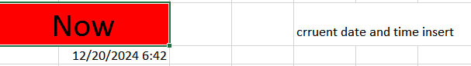

**Introduction to Cell Referencing:**

Here’s three types of Referencing.

* Relative
* Absolute
* Mixed

**Relative Reference:**

Copy address and row column not fix.

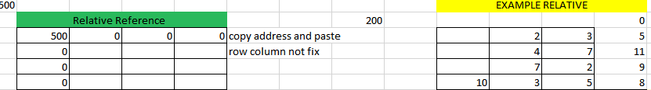

**Absolute Reference:**

Just press F4 only 1 time equal $ column $ row row and column fixed.

**Mixed Reference:**

Just press F4 time equal to column $row

Here’s two types of Mixed Reference:

* Row Locked Reference
* Column Locked Reference

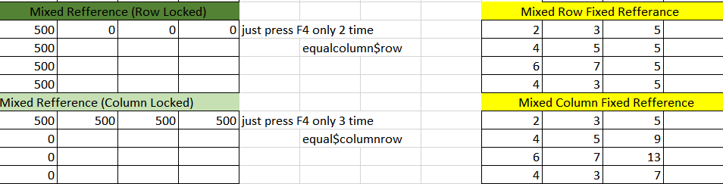

**Introduction to Sorting and Filtering Data:**

• **Sorting:** helps you organize data in a meaningful order (alphabetical, numerical, or by date).

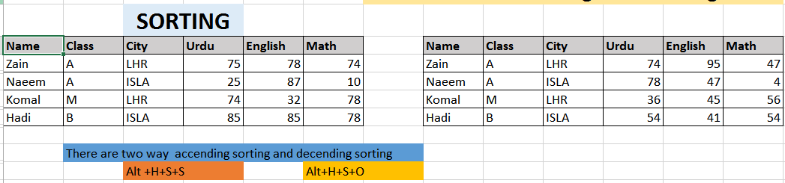•

**Filtering:** allows you to view only the data that meets specific criteria, making it easier to analyze large datasets.

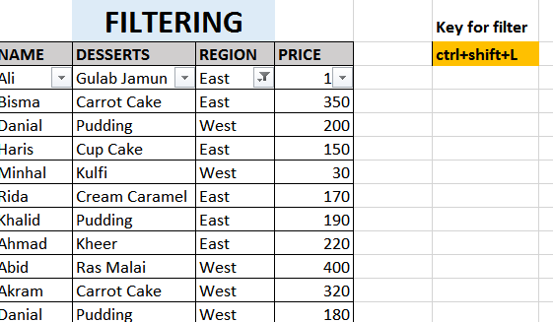

**LAB 09**

**Data Visualization and Advanced Features:**

**Data Visualization:**

Data visualization in Excel refers to the process of representing data in graphical formats, such as charts and graphs, to make it easier to understand and analyze. Excel offers a variety of visualization tools.

Charts (Line, Bar, Pie.)

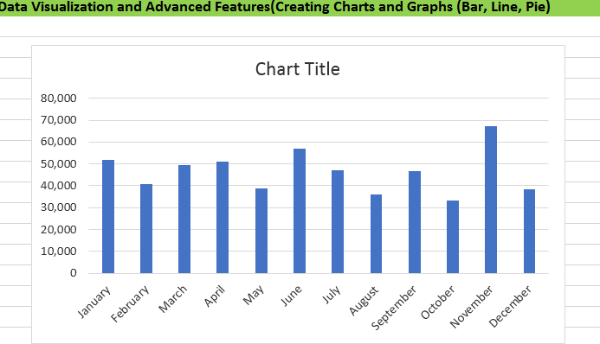

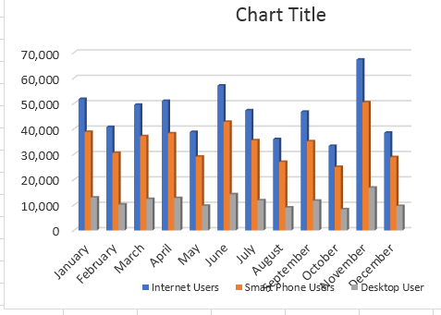

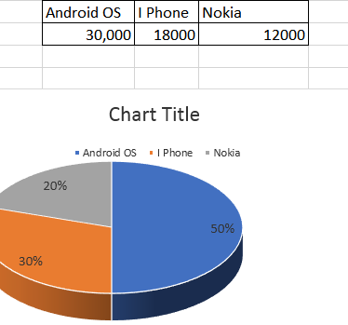

**Conditional Formatting**

Conditional formatting in Excel is a feature that allows you to apply formatting (such as color, font style, or cell borders) to cells based on specific conditions or rules.

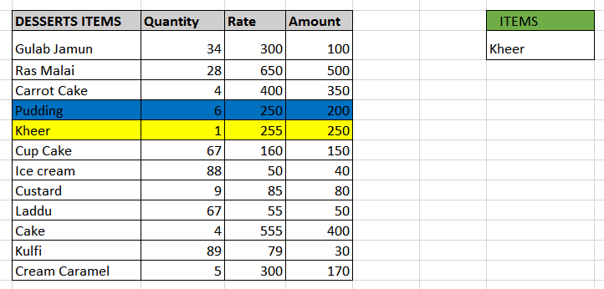

**Working with Tables and Data Validation**

To apply data validation in Excel:

1. **Select the cells** where you want validation.
2. Go to the **Data** tab and click **Data Validation**.
3. In the **Settings** tab, choose the validation type (e.g., number, date, list).
4. Set any specific rules (e.g., min/max values).
5. Optionally, add an **Input Message** and **Error Alert**.
6. Click **OK** to apply the validation.

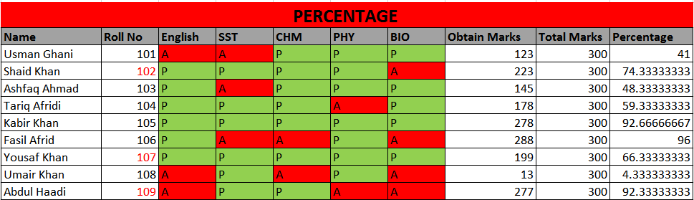

**Barcode:**

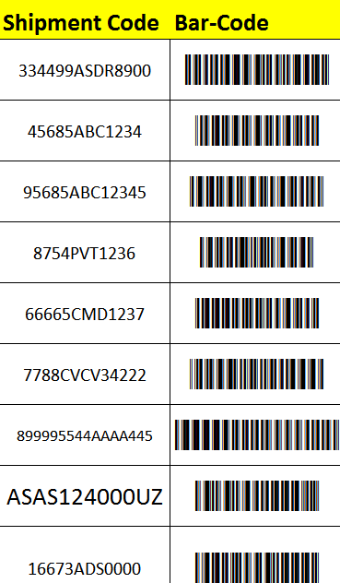

**QR Code:**

## 

## **Statistical Analysis Functions:**

* **COUNT:** Counts numbers in a range.

**Formula:** =COUNT (B1:B4)

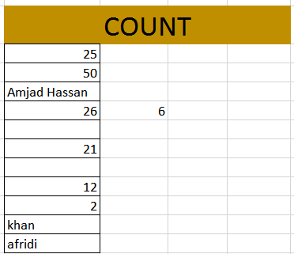

**• COUNTA:** Counts non-empty cells.

**Formula:** =COUNTA (A1:A5)

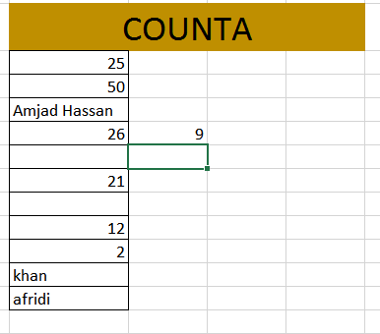

• **COUNTIF:** Counts cells that meet a condition.

**Formula:** =COUNTIF (A1:A5, 10)

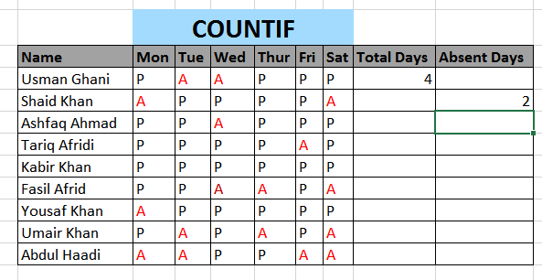

**LAB 10**

**Introduction to Pivot Tables, Using VLOOKUP and HLOOKUP**

A **Pivot Table** in Excel is a powerful tool that allows users to summarize, analyze, explore, and present large sets of data. It enables quick data aggregation, such as calculating totals, averages, or counts, and organizing data into categories for easy analysis.

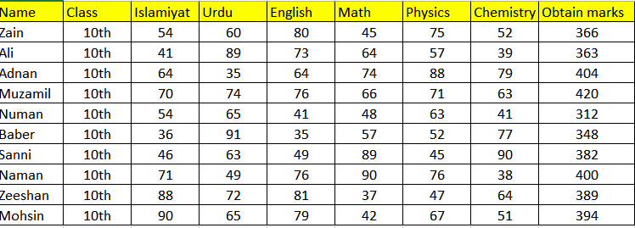

**VLOOKUP (VERTICAL LOOKUP):**

**What** **it does:** Searches for a value in the first column of a table and returns a value from another column in the same row.

**Formula:**

=VLOOKUP ("Banana", A1: B3, 2, FALSE)

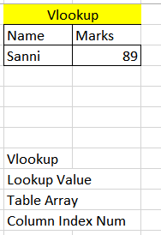

**HLOOKUP (HORIZONTAL LOOKUP):**

**What it does:** Searches for a value in the first row of a table and returns a value from another row in the same column

**Formula:**

=HLOOKUP ("Age", A1: C2, 2, FALSE)

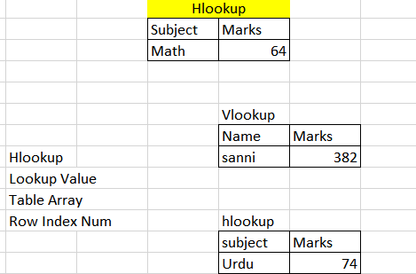

**Introduction to Macros:**

A **Macro** in Excel is a sequence of recorded actions or commands that automate repetitive tasks. It is written in **VBA (Visual Basic for Applications)** and can be used to perform complex operations with a single click or keyboard shortcut.

**Key points about macros:**

Automation

Recording

Execution

Customization